SOLEH ELFRIANTO HARDIYONO
2110147044
LJ PJJ 2014
PERTEMUAN 9

- ..
CREATE TABLE MY_EMPLOYEE
(
ID NUMBER(4),
LAST_NAME VARCHAR2 NOT NULL(25),
FIRST_NAME VARCHAR2(25),
USERID VARCHAR2(8),
SALARY NUMBER(9,2)
);

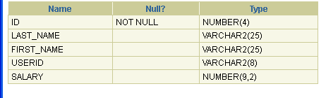
- ..
INSERT INTO MY_EMPLOYEE (LAST_NAME,FIRST_NAME,USERID,SALARY)
values (1,'Patel','Ralph','rpatel',795);
INSERT INTO MY_EMPLOYEE (LAST_NAME,FIRST_NAME,USERID,SALARY)
values (2,'Dancs','Betty','bdancs',860);
INSERT INTO MY_EMPLOYEE (LAST_NAME,FIRST_NAME,USERID,SALARY)
values (3,'Biri','Ben','bbiri',1100);
INSERT INTO MY_EMPLOYEE (LAST_NAME,FIRST_NAME,USERID,SALARY)
values (4,'Newman','Chad','cnewman',750);
INSERT INTO MY_EMPLOYEE (LAST_NAME,FIRST_NAME,USERID,SALARY)
values (5,'Roperburn','Audry','aropebur',1550);

- ..
Commit;
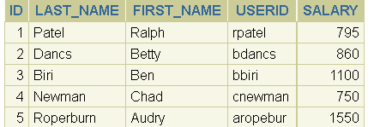

- ..
update my_employee set last_name = 'Drexler' where id=3;

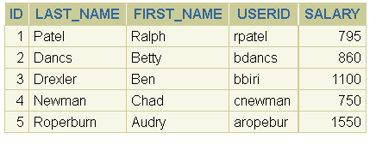
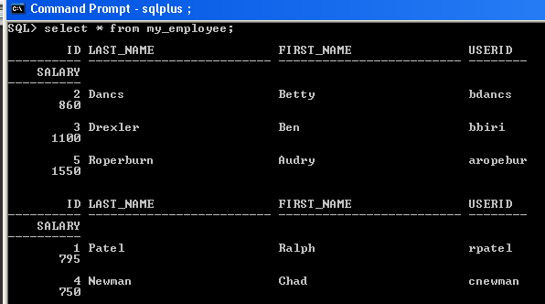
- ..
update my_employee set salary = 1000 where salary <900;
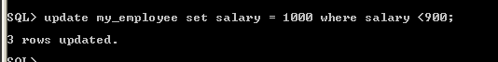

- ..
Select last_name, salary from my_employee;
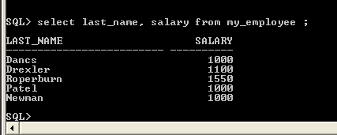
- ….
delete from my_employee where last_name = ‘Dancs';
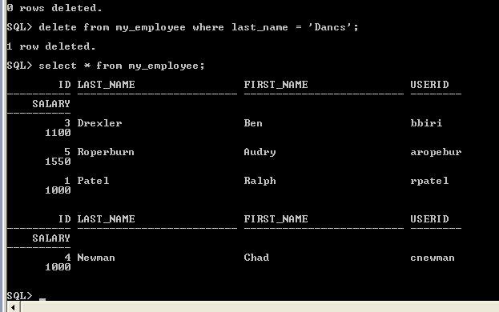

- ..
Commit;
- ..
SAVEPOINT sini;
- …
Delete from my_employee

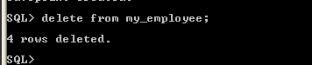
- …
Select * from my_employee;

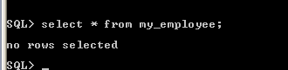

- …
Rollback;

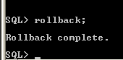

- …
Select * fom my_employee;

